**Applets**

**Packages required to import for an applet**

import java.awt.*;

import java.applet.*;

**Applet lifecycle or Applet initialization and termination**

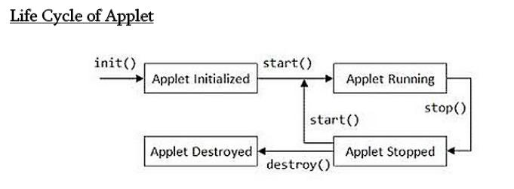

When an applet begins, the following methods are called, in this sequence:

* + **init( )**
  + **start( )**
  + **paint( )**
* When an applet is terminated, the following sequence of method calls takes place:
  + **stop( )**
  + **destroy( )**
* **init( ) :** 
  + The init( ) method is the first method to be called.
  + Initializing the variables.
  + This method is called only once during the run time of the applet.
* **start( ) :** 
  + Called after init( ).
  + Also called to restart an applet after it has been stopped.
  + Called each time an applet’s HTML document is displayed onscreen
* **paint( ) *:*** 
  + Called each time an applet’s output must be redrawn.
  + Also called when the applet begins execution.
  + The method has one parameter of type Graphics.
  + This parameter will contain the graphics context, which describes the graphics environment in which the applet is running.
* **stop( ) *:*** 
  + Called when a web browser leaves the HTML document containing the applet.
  + Used to suspend threads that don’t need to run when the applet is not visible.
  + We can restart them when start( ) is called.
* **destroy( ) :** 
  + called when the environment determines that the applet needs to be removed
  + completely from memory.
  + The stop( ) method is always called before destroy( ).

**Passing parameters to an applet**

**UseParam.java**

import java.applet.Applet;

import java.awt.Graphics;

public class UseParam extends Applet{

public void paint(Graphics g){

String str=getParameter("**msg**");

g.drawString(str,50, 50);

}

}

**Myapplet.html**

<html>

<body>

<applet code="UseParam.class" width="300" height="300">

<param **name**="*msg*" value="*Welcome to applet*">

</applet>

</body>

</html>

**Write a java applet program which handles keyboard event**

import java.applet.Applet;

import java.awt.*;

import java.awt.event.*;

/*

<applet code="Keyevents" width=300 height=400>

</applet>

*/

public class Keyevents extends Applet implements KeyListener {

char ch; String str;

public void init() // link the KeyListener with Applet

{

addKeyListener(this);

}

// override all the 3 abstract methods of KeyListener interface

public void keyPressed (KeyEvent e){

}

public void keyReleased (KeyEvent e){

}

public void keyTyped (KeyEvent e)

{

ch = e.getKeyChar();

if (ch == 'a')

str = "a for apple";

else if (ch == 'e')

str = "e for elephant";

else if (ch == 'i')

str = "i for igloo";

else if( ch == 'o')

str = "o for ox";

else if(ch == 'u')

str = "u for umbrella";

else

str = "Type only vowels a, e, i, o, u only";

repaint();

}

public void paint(Graphics g) {

Font font = new Font("Arial",Font.BOLD,30);

g.setFont(font);

g.setColor(Color.blue);

g.drawString(str, 100, 150);

showStatus("You typed " + ch + " character");

}

}